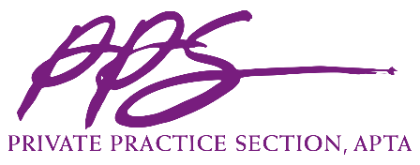

Private Practice Section (PPS) Speaker Agreement
PPS Annual Conference

This Agreement (“Agreement”) documents the relationship between the Private Practice Section of the American Physical Therapy Association (“PPS”), a Nevada not-for-profit corporation with headquarters at 1055 North Fairfax Street, Suite 204 Alexandria, Virginia 22314 and the “Speaker.” The parties agree to the following terms and conditions:

- The Speaker agrees to present at the 2019 PPS Annual Conference: [insert session title]

- Speaker agrees to comply with all PPS Presentation-related deadlines provided to Speaker between the date of this Agreement and the presentation date. The definition of “Presentation” as used herein shall include, but not be limited to, handouts, slides/PowerPoint, graphs, charts, references, figures, illustrations, text, videos segments and photos that Speaker may provide in connection with the Presentation. Deadlines may include, but not be limited to, deadlines for providing: Presentation title, a description of the Presentation, the learning objectives of the Presentation, presenter’s photograph, biography and references, media/multimedia handouts, PowerPoint, graphics, and/or computer generated elements of the Presentation. Speaker will also agree to register for the Conference and submit a handout for distribution to attendees by the deadlines set by PPS.

- Speaker will notify PPS’s Executive Director immediately in the event that an emergency will prevent Speaker from meeting the obligations as Speaker.

- For the Presentation, and in consideration of the terms and conditions of this Agreement, PPS shall compensate Speaker the following:

For a Pre-Conference Workshop or Breakout Session:
  - Honorarium: $150 per hour for the length of the session. If more than one speaker, this honorarium will be divided equally among all speakers and will be paid directly to each speaker.

  - Conference Registration (speakers may select one option via the survey):
    - Complimentary for day of Presentation (preconference speakers, please identify the day below);
      - Thursday, October 31
      - Friday, November 1
    - $560 for the full conference.

  - Travel Related Expenses: Up to $500 total expenses (travel and meals), upon presentation and acceptance of original documentation/receipts by PPS within the deadline set by PPS. Speaker must submit documentation/receipts with a completed and signed PPS Expense Reimbursement Form.

  - Lodging: Reimbursement for one night’s lodging at the specified Conference Host Hotel including applicable taxes, with original documentation/receipts by PPS within the deadline set by PPS.

- PPS and Speaker agree that there are no fees, payments and/or commissions due to any third-party relative to this Agreement, including but not limited to brokers or speaker’s bureaus.

- PPS may capture the Presentation and use the content of the Presentation, in whole or part, for the benefit of its members.

- The Speaker hereby grants to PPS a royalty-free, irrevocable worldwide transferable license to use Speaker’s name, likeness, photograph and biographical data in connection with the use, broadcast, publication, distribution and promotion of the Presentation.

- The Speaker retains the copyright to anything the Speaker creates (“Speaker Materials”). The Speaker, as the copyright holder to the Speaker Materials, can use what the Speaker creates in any way the Speaker chooses. PPS retains the copyright to anything PPS creates. The Speaker hereby grants to PPS a royalty-free, exclusive, irrevocable worldwide transferable license to capture, use, reproduce, distribute, publicly perform, transmit, digitally perform, publicly display, translate, stream on the internet, or post on its website.

- The Speaker represents and warrants that the Presentation and any other material submitted by the Speaker, are original works of authorship solely of the Speaker and if not, that the Speaker has accurately referenced any third party or has sufficient and full power from any third party owner to grant PPS the rights and license set forth herein and that use as set forth in this Agreement will not infringe on the rights of any third party. Speaker agrees to indemnify, hold harmless and defend PPS for any liability, claim, claim of infringement, cause of action, litigation, demand, order, judgment of any type or nature that arises from or relates to Speaker’s breach or violation of the terms and conditions of this Paragraph 9.

- Speaker understands that he/she will not receive any royalties, honoraria, reimbursement of expenses (except to the extent approved as set forth herein), or other compensation from PPS in connection with the Presentation and/or the rights and licenses granted herein.

- During the Presentation, Speaker will not engage in any type of promotional marketing or selling of any product or service and will not disparage PPS in any way. Speaker understands that he/she should disclose any relationship or financial benefit that could reasonably be viewed as creating a conflict of interest, or the appearance of a conflict of interest, that might bias the content of their presentation.

- A failure or delay of either party to this Agreement to enforce at any time any of the provisions of this Agreement, to exercise any option which is herein provided or to require at any time performance of any of the provisions hereof shall in no way be construed to be a waiver of such provision of this Agreement.

- This Agreement is not intended to and does not create any form of joint enterprise, partnership, joint venture or any other business arrangement apart from the terms of this Agreement. Speaker acknowledges that he/she is an independent contractor, and that he/she is not acting as an agent of PPS.

- This Agreement contains the entire agreement between the parties with respect to the subject matter contemplated herein, and it supersedes all prior oral or written commitments, understandings, or agreement with respect to the subject matter contemplated herein.
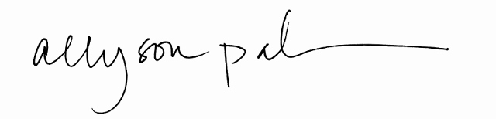
Private Practice Section, APTA

By: ______________________________________________________________ ___________
Allyson Pahmer Date
Executive Director, PPS

Speaker: [Insert Speaker First and Last Name]

By: __[obtain electronic signature] [date of signature]

