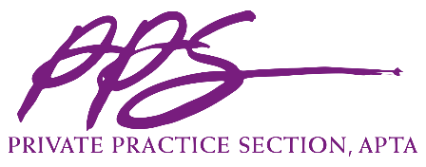

Private Practice Section (PPS) Conference Speaker Agreement

This Agreement (“Agreement”), made on this 27th day of June, 2018, documents the relationship between the Private Practice Section of the American Physical Therapy Association (“PPS”), a Nevada not-for-profit corporation with headquarters at 1055 North Fairfax Street, Suite 204 Alexandria, Virginia 22314 and the “Speaker.” The parties agree to the following terms and conditions:

- The Speaker agrees to present at the 2019 PPS Annual Conference Buzz Session:

- Speaker agrees to comply with all PPS Presentation-related deadlines provided to Speaker between the date of this Agreement and the session date. The definition of “Presentation” as used herein shall include, but not be limited to, handouts, slides/PowerPoint, graphs, charts, references, figures, illustrations, text, videos segments and photos that Speaker may provide in connection with the Presentation. Deadlines may include, but not be limited to, deadlines for providing: Presentation title, a description of the Presentation, the learning objectives of the Presentation, presenter’s photograph, biography and references, media/multimedia handouts, PowerPoint, graphics, and/or computer generated elements of the Presentation. Speaker will also agree to register for the Conference and submit a handout for distribution to attendees by the deadlines set by PPS.

- Speaker will notify PPS’s Executive Director immediately in the event that an emergency will prevent Speaker from meeting the obligations as Speaker.

- For the Presentation, and in consideration of the terms and conditions of this Agreement, Speaker will receive the following compensation:
  - Complimentary registration for the day of the Presentation or a discounted rate of $560 for a full registration to the conference;
  - An honorarium of $150 for the length of the session (1.5 hours = $225 total), to be split evenly among speakers.

- PPS and Speaker agree that there are no fees, payments and/or commissions due to any third-party relative to this Agreement, including but not limited to brokers or speaker’s bureaus.

- The Speaker hereby grants to PPS a royalty-free, irrevocable worldwide transferable license to use Speaker’s name, likeness, photograph and biographical data in connection with the use, broadcast, publication, distribution and promotion of the Presentation.

- The Speaker retains the copyright to anything the Speaker creates (“Speaker Materials”). The Speaker, as the copyright holder to the Speaker Materials, can use what the Speaker creates in any way the Speaker chooses. PPS retains the copyright to anything PPS creates.

- The Speaker represents and warrants that the Presentation and any other material submitted by the Speaker, are original works of authorship solely of the Speaker and if not, that the Speaker has accurately referenced any third party or has sufficient and full power from any third party owner to grant PPS the rights and license set forth herein and that use as set forth in this Agreement will not infringe on the rights of any third party. Speaker agrees to indemnify, hold harmless and defend PPS for any liability, claim, claim of infringement, cause of action, litigation, demand, order, judgment of any type or nature that arises from or relates to Speaker’s breach or violation of the terms and conditions of this Paragraph 8.

- Speaker understands that he/she will not receive any royalties, honoraria, reimbursement of expenses (except to the extent approved as set forth herein), or other compensation from PPS in connection with the Presentation and/or the rights and licenses granted herein.

- During the Presentation, Speaker will not engage in any type of promotional marketing or selling of any product or service and will not disparage PPS in any way. Speaker understands that he/she should disclose any relationship or financial benefit that could reasonably be viewed as creating a conflict of interest, or the appearance of a conflict of interest, that might bias the content of their presentation.

- A failure or delay of either party to this Agreement to enforce at any time any of the provisions of this Agreement, to exercise any option which is herein provided or to require at any time performance of any of the provisions hereof shall in no way be construed to be a waiver of such provision of this Agreement.

- This Agreement is not intended to and does not create any form of joint enterprise, partnership, joint venture or any other business arrangement apart from the terms of this Agreement. Speaker acknowledges that he/she is an independent contractor, and that he/she is not acting as an agent of PPS.

- This Agreement contains the entire agreement between the parties with respect to the subject matter contemplated herein, and it supersedes all prior oral or written commitments, understandings, or agreement with respect to the subject matter contemplated herein.
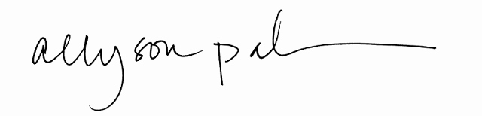
Private Practice Section, APTA

By: ______________________________________________________________ _6/27/2018____
Allyson Pahmer Date
Executive Director, PPS

Speaker

By: ____________________________________________________________ ___________
[insert speaker first and last name] Date

