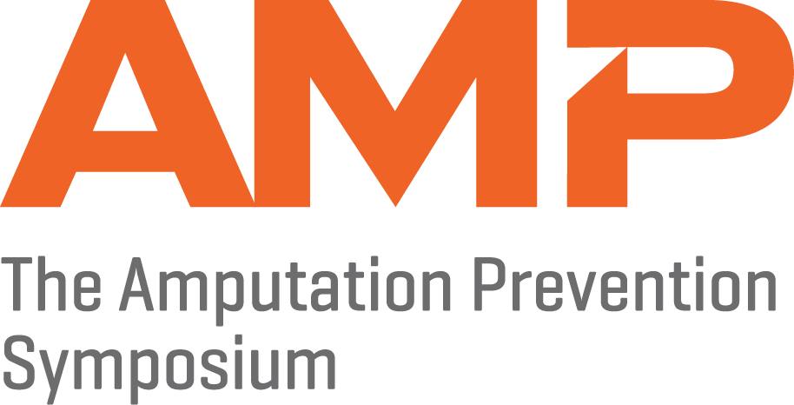

ABSTRACT SUBMISSION GUIDELINES
The deadline for abstract submission is 11:59 pm Eastern on Sunday, June 17, 2018.
All abstracts must be submitted electronically via the official AMP abstract submission website. Paper abstract submissions will not be accepted.

NOTIFICATION AND TERMS OF ACCEPTANCE
Notifications of abstract acceptance or rejection will be e-mailed to the abstract submitter the week of July 2. The submitter is responsible for relaying all correspondence to abstract authors. Authors whose abstracts are selected for poster display will be responsible for travel and accommodations but will be eligible for a registration discount of 50% off for the first author and 25% off for subsequent authors. Any details concerning registration discounts will be provided in the acceptance notification. If accepted, authors must notify AMP of their participation by e-mailing Emily Gibson at egibson@naccme.com and registering for the meeting. Please note: AMP will not hold or guarantee space for poster displays until notified of the author’s participation.
IMPORTANT NOTES FOR SUBMITTERS
- Abstracts must include the following parts:
  - Purpose
  - Material and Methods
  - Results
  - Conclusions

- Do not re-enter the abstract title or the authors' names/institutions in the text portion of the submission.
- Do not enter images or tables in the text portion of the submission.
The final abstract length cannot exceed 2,500 characters total.
All accepted abstracts will be poster presentations displayed at AMP. The poster size should be no larger than 8' wide x 4' high (243 cm x 121 cm). The orientation for posters is horizontal.

Author and Affiliation Information
- The authors in the author list should be listed in the order that they should appear in program materials.
- List the complete name including a full first name, middle initials, last name, and credentials for each author, as it should appear in program materials.
- Please do not include author institutions, or contact information in the author list, or body of the abstract. If you enter author’s institutions or contact information in the author list or abstract body, they will be removed.
- An author’s name may appear on multiple abstracts, but if possible, they should appear exactly the same to assist with indexing of the abstracts.

References
- References are optional. Please limit references to the 10 most pertinent citations.

Abstract Title
- The abstract title should adequately convey the content of the abstract and should be entered using Proper Case. Please avoid use of abbreviations and do not exceed 120 characters, including spaces.
PRIOR PRESENTATION/PUBLICATION
Authors must affirm that if this abstract has been presented previously, the meeting location and date are identified. Abstracts previously presented, accepted for presentation, or submitted for presentation at any other meeting may be submitted for presentation. However, if another professional organization has publication rights to the work, the work cannot be submitted to AMP unless the author obtains a written waiver from the other professional organization.
Poster Numbers
Poster numbers will be assigned in early July and primary contacts will be notified via email.
No-Show Policy
On rare occasions, presenters scheduled to present their poster fail to show up and have not notified AMP of the change in plans. When presenters do not appear to present their poster, the planning efforts of the Abstract Committee in providing a quality program are diminished significantly, there are significant cost implications, and the audience is unnecessarily disappointed with empty poster boards. Staff will audit all posters for no shows and this may result in ineligibility for future AMP meetings.
Withdrawals
Acceptance of the abstract by the review committee obligates the author to be present. If circumstances prevent attendance, the author must arrange for the poster to be presented by a substitute, preferably a co-author. If you wish to withdraw your abstract, you must submit your request in writing by Friday, July 13, 2018 to Emily Gibson at egibson@naccme.com including the abstract title and first author. Failure to comply may result in ineligibility for future AMP meeting abstract submissions as first author.
Important Deadlines
Abstract Submissions Site Open: Friday, May 4, 2018
Abstract Submissions Site Closed: Sunday June 17, 2018 at 11:59 p.m.
Acceptance/Decline Notifications: Week of July 2, 2018
Registration/Intent to Present or Withdrawal Due: Friday, July 13, 2018
QUESTIONS?
For questions regarding the abstract process, please contact Emily Gibson at egibson@naccme.com or at (609) 371-1137 extension 5232.

