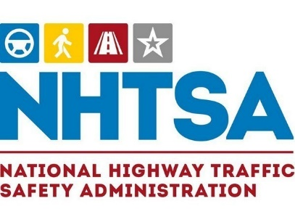

Public Service Awards - Call for Nominations

The NHTSA Public Service Awards, presented each year at Lifesavers, recognize and honor the outstanding achievements of an individual or organization in the field of traffic safety. Awardees advance NHTSA’s mission to save lives, prevent injuries, and reduce economic costs due to road traffic crashes, through education, research, safety standards and enforcement activity.

Nomination Guidelines
Nominate an individual or an organization who exemplifies exceptional commitment and contribution to saving lives and making our roads safer. Nominee should demonstrate strong leadership. He/she or the organization is considered a traffic safety leader in his/her field who brings people from diverse backgrounds together to resolve an existing or emerging traffic safety issue.

Individuals may conduct activities as a volunteer, an advocate, in a civic capacity, as a law enforcement official, or as a highway safety professional (state highway safety office staff, state department of transportation staff and US DOT employees are not eligible).

Please keep in mind that this is not meant as a retirement award. If you know someone that is ending an exceptional and robust career in traffic safety, you may include additional information on overall career achievements. In rare instances, NHTSA may consider awarding a Lifetime Achievement Award. This award has only been presented a few times over several decades.

Criteria for Evaluating a Nominee
Use the five criteria/qualifications below when considering your nominee:
- Nominee’s achievement/work exemplifies the development of an innovative or unique approach to address a traffic safety issue resulting in the reduction of motor vehicle crashes and injuries.
- Nominee’s achievement/work has resulted in impactful changes or outcomes related to improving/addressing a traffic safety issue.
- Nominee’s work/achievement has resulted in impactful action (legislation, program development, community mobilization) that addresses a traffic safety issue.
- Nominee demonstrates strong leadership. He/she or the organization is considered a safety leader in his/her field and can bring people from various backgrounds together to solve a safety issue.
- Nominee’s achievement/work can be adopted and adapted as a best practice in other communities/states.

Eligibility
- Nominee must be an individual or organization who has conducted an exceptional program or activity as a volunteer, an advocate, in a civic capacity, as a law enforcement official or as a highway safety professional (state highway safety office staff, state department of transportation staff and US DOT employees are not eligible).
- Nominees who are a past recipient of the Public Service Award will not be accepted. View a list of previous award winners here.
- Self-nominations will not be accepted.

Who Can Nominate
State highway safety offices, State departments of transportation, law enforcement agencies, public health agencies, traffic safety advocates and NHTSA regional offices.

How to Nominate
Nominators must complete the nomination form on this site. When the nomination process closes, nominees will be sorted by NHTSA region (based on where the individual or organization is located) and forwarded to the appropriate NHTSA Regional Administrator. NHTSA Regional office staff will score the nominee based on a set of criteria, then submit the top five nominations to the NHTSA HQ Award Committee.

You will receive acknowledgement that the nomination has been received.

Incomplete nomination forms will not be considered.

