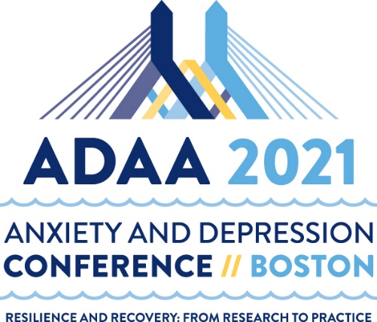

2021 Conference Submission Checklist

Primary Presenters/Chairs should have the following information ready before beginning their submission:
- Title
- Session Abstract/Description (2500 characters/350 words)
- Three Educational Learning Objectives
- Target Audience Level, Demographic, Disorder, and Treatment Approach Keywords
- Session Length (Roundtable: 60 minutes/Ignite Symposia: 60 or 90 minutes/Workshop: 60 or 90 minutes/Symposia: 60 or 90 minutes)
- Co-presenter(s) name, degree, degree area of specialty, affiliation and email address
- Workshop Outline (Master Clinician and Workshops Only, 2500 characters/350 words)

- The primary presenter/chair can create, update, change, and finalize a submission.

- The primary presenter/chair may be the chair, presenter, or discussant and provides the title, session abstract, target audience level, learning objectives and designates session length.

- The primary presenter/chair must provide the name, degree, affiliation, email address, and contact information for each presenter. Individual presenters will be notified when a session is selected and will be prompted to login and provide/update their contact information, complete their disclosure and registration agreement, and add title/abstract (for symposia only).

- The primary presenter/chair must finalize the submission once all information is complete.

- All submissions may be modified until the deadline even if finalized and must be complete by the deadlines listed below to be reviewed. View the “How to Submit” guidelines (found on the submissions portal login page) for additional submission details.

Submission Type | Deadline
Master Clinician Sessions | Wednesday, October 7, 2020
Symposia, Ignite Symposia, Workshops, Roundtables | Wednesday, October 7, 2020
Alies Muskin CDLP, CDLP Mentor, and Donald F. Klein Award | Wednesday, November 4, 2020
New Research Posters | Wednesday, November 4, 2020

Please email any questions to: conference@adaa.org

